Trimmer’s function and LEDs’ indicate on S10017

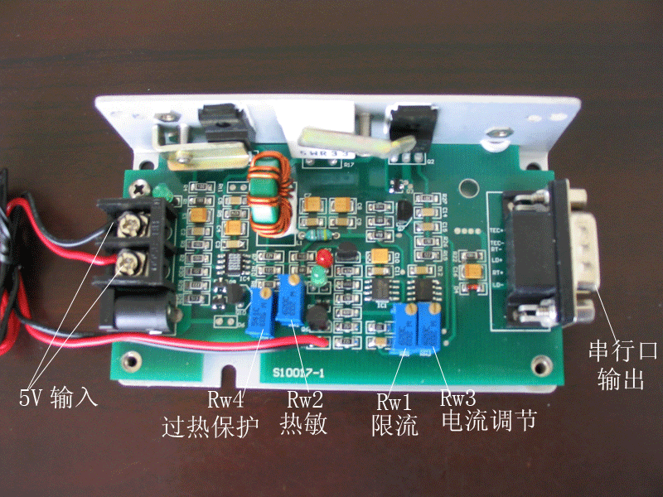
Rw2 -to adjust the temperature control of the laser, clockwise to increase the temperature, anti-clockwise to decrease the temperature.
Rw1 -to set the limit of the current. This trimmer is prohibited to be changed unless authurized.
Rw3 -to change the current of the pump diode. To turn clockwise to decrease the current; anti-clockwise to increase the current. Take special care to turn anti-clockwise. If the laser output doesn’t increase, donot turn anti-clockwise, otherwise the laser will be ruined.

The leds-
- The green on the side to indicate 5V on
- The led in the middle turns on green to indicate laser on after delay
- The led in the middle turns red to indicate protection on and laser off

